**11.Arduino UNO platform ------- voltage_detection**

1. **Preparation**

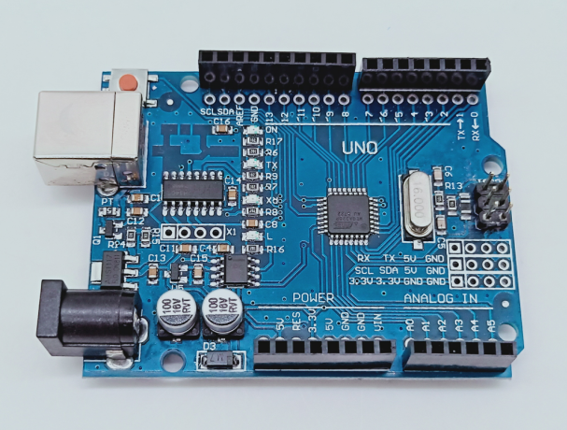

1-1 Arduino UNO board

**2)Purpose of Experimental**

After the code upload is completed. You can see the battery voltage of the car by the serial monitor of the Arduino IDE.

**3)Principle of experimental**

The analog port of Arduino can detect 0-5V voltage, corresponding to the value of 0-1023.

According to principle of equal current, we can obtain: Vm/（R14+R15）= Vad/R15. According to detecting by Arduino UNO,we can obtain:Vad= (AD/1023)*5.

Vm/（R14+R15）= Vad/R15 -----------①

Vad= (AD/1023)*5 ---------------②

From ①、②，we can obtain this formula:

Voltage = (Voltage / 1023) * 5 *（R14 + R15）/ R15-0.35

Note: 5----Standard voltage of the Arduino UNO

Voltage----The AD value collected by port A0(0-1023)

1. ---（R14+R15）/R15 (R14=20K,R15=10K)

0.35----An adjustment value due to the accuracy of the resistor.

**4)Experimental Steps**

4-1 About the schematic

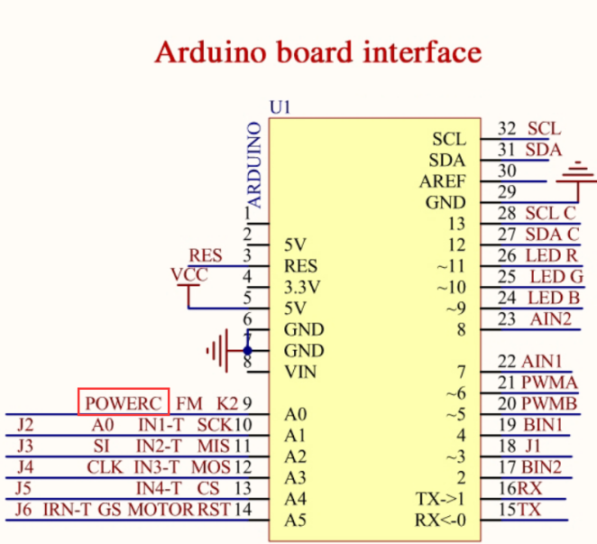

4-1 Arduino UNO interface circuit diagram

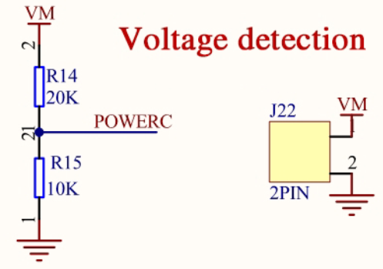

4-2 Battery voltage detection circuit

4-2 According to the circuit schematic:

POWERC-----A0(Arduino UNO)

4-3 About the code

1. We need to open the code of this experiment:**voltage_detection.ino**, click“**√**” under the menu bar to compile the code, and wait for the word "**Done compiling** " in the lower right corner, as shown in the figure below.

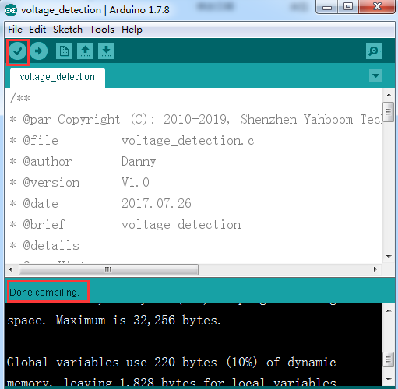

2.In the menu bar of Arduino IDE, we need to select 【Tools】---【Port】--- selecting the port that the serial number displayed by the device manager just now, as shown in the figure below.

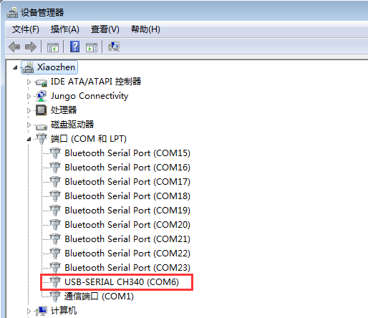

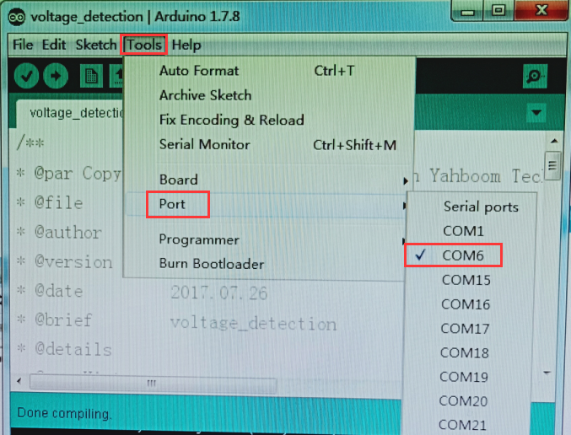

3.After the selection is completed, you need to click “**→**”under the menu bar to upload the code to the Arduino UNO board. When the word “**Done uploading**” appears in the lower left corner, the code has been successfully uploaded to the Arduino UNO board, as shown in the figure below.

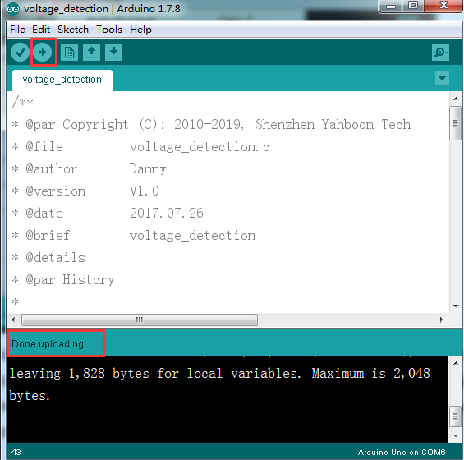

4.After the code is uploaded. You need to open the serial port monitor on the top right corner of Arduino IDE, and Set the serial port baud rate to 9600. You will see that the current voltage value of the car is printed.